

Nanayakkara S.N.N.

IT24101675

Exercise

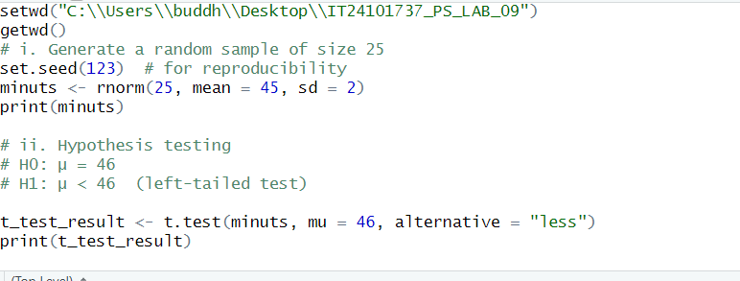

Figure 1.1: R script Question answers

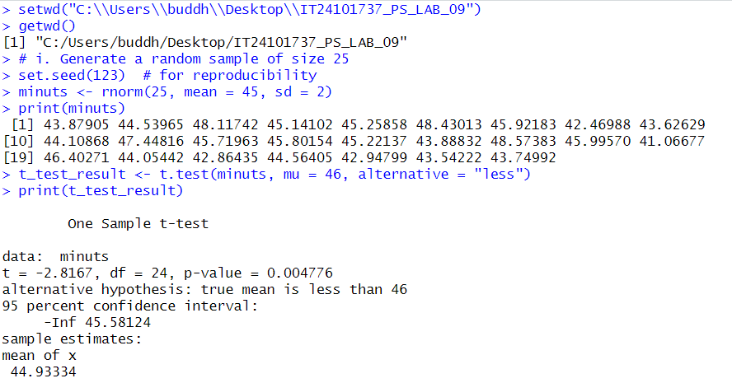

Figure 1.2: console part